MCC PDBI Renewal information

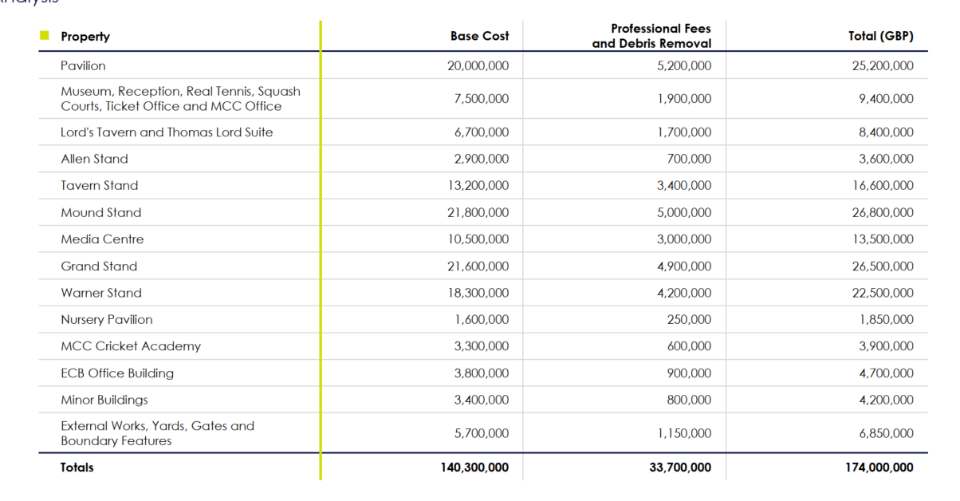

**ALL OTHER PROPERTY**

|  |  |  |
| --- | --- | --- |
| **Item** | 2021 | 2022 |
|  |  |  |
| **Stock of Shop: Retail On-site: Out of cricket season** | | | |
| Low | 250,000 | 250,000 |
| High | 420,000 | 420,000 |
| **Stock of Shop: Retail On-site: In cricket season** | | | |
| Low | 450,000 | 450,000 |
| High | 700,000 | 700,000 |
| **Stock of Food at Lord’s and Lord’s Tavern Bar and Brasserie Out of cricket season** | | | |
| Low | 25,000 | 25,000 |
| High | 35,000 | 35,000 |
| **Stock of Food at Lord’s and Lord’s Tavern Bar and Brasserie: In cricket season** | | | |
| Low | 35,000 | 35,000 |
| High | 60,000 | 60,000 |
| Test Match Maximum | 150,000 | 150,000 |
| **Stock of Drink at Lord’s and Lord’s Tavern Bar and Brasserie Out of cricket season** | | | |
| Low | 100,000 | 100,000 |
| High | 140,000 | 140,000 |
| **Stock of Drink at Lord’s and Lord’s Tavern Bar and Brasserie: In cricket season** | | | |
| Low | 170,000 | 170,000 |
| High | 325,000 | 325,000 |
| Test Match Maximum | 500,000 | 500,000 |
| **Stock held at various suppliers (packaging prior to product inclusion, cloth prior to cutting, Laws of Cricket booklet, postcards etc.)** | 15,000 | 15,000 |
| **Mobile Phones** | 41,600 (to replace as new (current value £20,800)) | 50,000 (to replace as new (current value £18,000)) |
| **CCTV Equipment** | 308,000 | 380,000 |
| **Fork Lift Truck** | 9,000 |  |
| **Cricket Table and Outfield** | 160,000 | 160,000 |
| **House: 4 Grove End Road NW8 9LB** | 1,260,000 | TBC |
| **House: 12 Grove End Road NW8 9LB** | 1,440,000 | TBC |
| **House: 6 Grove End Road, London NW8 9LB** | 1,260,000 | TBC |

BUSINESS INTERRUPTION

|  |  |  |  |
| --- | --- | --- | --- |
| Customer and Supplier | | | |
| Customer | Total Value of Sales | Gross Margin on Sales | Address (incl Postal Code where applicable) |
| J.P. Morgan Chase Bank | £1.25m |  | 20 Bank Street, London E14 5JPE |
| Supplier | Total Value of Purchases | Gross Profit Exposed | Address (incl Postal Code where applicable) |
| England and Wales Cricket Board | £5.5m |  | Lord’s Ground, London NW8 8QZ |
|  |  |  |  |

MONEY

|  |  |  |
| --- | --- | --- |
| **Description** | 2021 | 2022 |
| **Non-negotiable money - Crossed cheques postal orders/money orders** | 240,000 | 240,000 |
|  |  |  |
| **In transit – MCC Employees** | 10,000 | 10,000 |
|  |  |  |
| **In transit Security Company:** | | |
| **Standard** | 100,000 | 20,000 |
| **Seasonal Increase - annual holidays, Christmas, and Major Match days** | 0 | 0 |
|  |  |  |
| **In the Insured’s premises during Business Hours:** | | |
| **Non-match days maximum limit across all safes** | 128,000 | 80,000 |
| **Major Match Days** | 400,000 | 80,000 |
|  |  |  |
| **Bank Night Safe** | 10,000 | 1,000 |
|  |  |  |
| **Within the Insured's premises out of business hours not contained in a locked safe or strong room** | 5,000 | 5,000 |
|  |  |  |
| **Within the Insured's premises out of business hours contained in locked safe(s) or strong rooms (to be specified below)** | 400,000 | 80,000 |
|  |  |  |
| **In the private residence of the Insured or an authorised employee** | 500 | 500 |